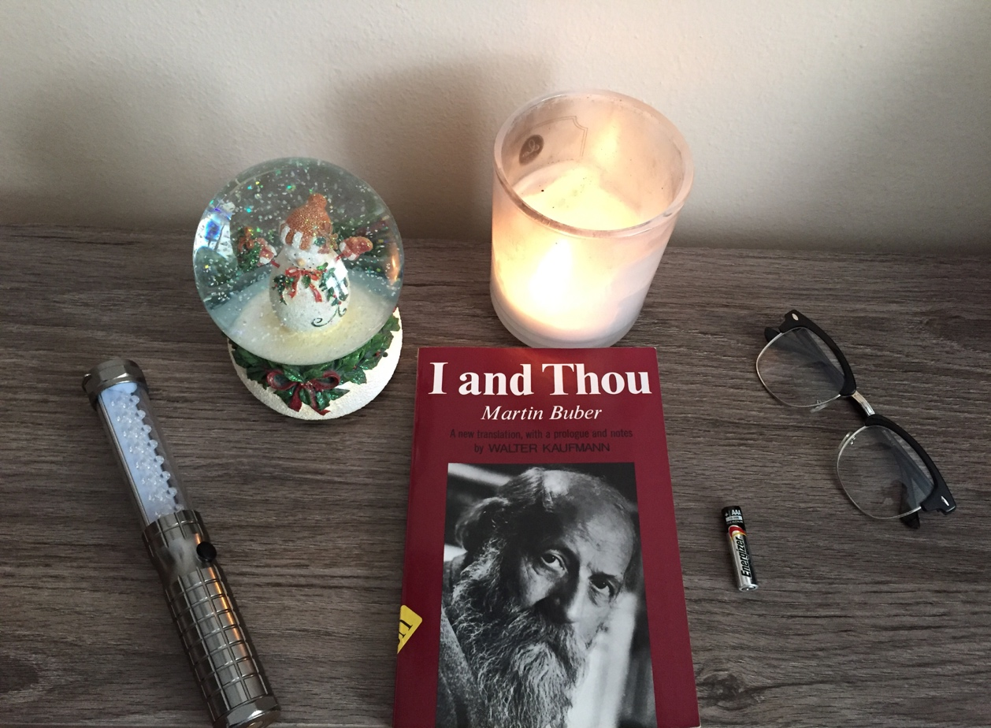

Tuan Nguyen

Book Bento for I and Thou by Martin Buber

Crystal Ball

The man’s world is manifold as a crystal ball. Although a crystal ball looks basic and essential, it contains many elements inside, such as a snowflake, water, oil, and snowman. Like, Buber describes the man’s world is unified and manifold because it’s not simple and neat. Inside the crystal ball, man can see the world in two ways. One way is seeing the world as simple and common. Other way is seeing the world as superior and frighten. Like, the crystal ball is clear and easy to spot object when there is no snowflake flow around. Moreover, Burbler describes the word manifold is often frightening because of the wrong decision that people make in life. They can choose to follow the path that other recommend or they can choose their own path. However, some path can lead to a wretched life. For example, Buber says, “To walk far on this path may be difficult, but the choice is easy, and to hear the celebration of this path is pleasant.” It contains many mean and relation to the man’s world. The decision can be easy as a yes or no to something, but the outcome can create a huge impact on the life.

Flashlight

A flashlight is used to see or explore things in the dark. For instance, Buber says, “Man goes over the surface of things and experience them. He brings back from them some knowledge of their condition-an experience. He experiences what there is to things” (p.55). By using a flashlight, people can see things clearer and explore the dark. When a flashlight is on, the world is visible. The true can be easily spot and profound. The world can seem to be colorful and fascinate to live. However, when a flashlight is off, the world cover in the dark. The suffer and miserable cover the mind. The experience becomes narrow and limit. The difference between the true and lies overlap. Like, a man can’t separate the true between the experience and the condition of the place when he is in the dark.

Fire

A fire can keep warm, but also can burn things. Fire can be a benefit, but also can be harmful. For example, the word “I” in “I-You” is different from the word “I” in “I-It”. When one said “I-You”, it refers to a person; and when one said “I-It”, it refers to an object. The “I” can have different mean when it pairs with another word. The subject is changed and the object is referred to another thing. Like a fire can be a benefit because it keeps people warm, but also it can be a harm because people can get burn. When using the I and It in a sentence, the subject can refer to one or the other. For instance, Buber mentions “When I confront a human being as my You and speak the basic word I-You to him, then he is no thing among things nor does he consists of things” (p.59). Word can represent a specific mean and sound when used in various ways.

Battery

A Battery shows the force of love is strong, but not durable. A battery can only last a certain time, such as love doesn’t last forever. In I and Thou, Buber emphasizes love is a cosmic force that good and evil intervolved. Love is clever, foolish, beautiful and ugly. Like the new battery is useful, but the old battery is useless. When love doesn’t exist anymore, people begin to see the ugly and foolish of the other. Like, the new battery is replaced the old one. Love is tasteless and plain because it doesn’t consist the feeling and emerging of "an I for a You" into something unique.

Glasses

The Glasses is useful to see an object in different shapes, structures, and colors. Like, the It-world described by Buber is the world of diversity of human race. For instance, Buber says, “People point out that successive cultures begin with a primitive stage that is colored differently but always has essentially the same structure” (p.87). The world that created by our ancestors, both of different colors and ethics but the same structure. The world involved many small objects as the component of individual culture. Each culture has its own tradition, influence, belief, language, and rule. The It-world can be the world of your own fate that no one enters.